Practicum Final Exam –Even Semester Year 2020/2021
Subject |  |  | COMP6048 - Data Structures |  |  | 
Class | : | B601 / BA05 / BB08 / BC02 / BM01 / BQ01 / BS01 / PA01 / PC01 |  | Start Date | : 17 June 2021
Lecturer | : | D4456 - Dennise Adrianto, S.Kom., M.T.I.  D5025 - Yovita Tunardi, S.Kom., M.T.I  D5337 - Yudy Purnama, S.Kom, M.TI  D5387 - Harvianto, S.Kom, M.T.I.  D5874 - Irene Anindaputri Iswanto, S.Kom., M.Sc.Eng.  D6414 - Kristien Margi  D6416 - Puti Andam Suri, S.Kom, M.TI  D6421 - Muhammad Fikri Hasani, S.Kom., M.T.  D6426 - Kenny Jingga, S.Kom., M.T. |  | Start Time | : 07:20
Lecturer | : |  |  | End Date | : 17 June 2021
Lecturer | : |  |  | End Time | : 09:20

PERATURAN UJIAN:
Exam Regulations:
- Mahasiswa tidak diperbolehkan berdiskusi dan/atau bekerja sama dengan peserta ujian lainnya
Student is not allowed to discuss and/or work together with other exam participants
- Mahasiswa tidak diperbolehkan untuk membuka dan menyalin dari BUKU atau CATATAN, VIDEO dari pengajar (recording kelas, VBL, Youtube, dsb) dan REFERENSI lainnya
Student isn't allowed to open and copy from any resources such as notes, videos (class recording, VBL, Youtube, etc) and other references
- Mahasiswa tidak diperbolehkan membuka dan menyalin jawaban dari internet (google, stackoverflow, dsb)
Student isn't allowed to open and copy answer from the internet (google, stackoverflow, etc)
- Asisten BERHAK memberi nilai 0 (NOL) bagi peserta ujian yang melakukan segala bentuk kecurangan
Assistant is able to give 0 (ZERO) score for exam participant who does any cheating actions
- Kumpulkan jawaban tepat pada waktunya, apabila terlambat mengumpulkan maka jawaban tidak akan dikoreksi dan nilai mahasiswa adalah 0
Submit the answer on time, if not, then the answer will not be checked, and the students will receive 0 (ZERO)
- Bila Anda tidak membaca peraturan ini, maka Anda dianggap telah membaca dan menyetujuinya
If you have missed to read these regulations, so you are considered to have read and agreed on it

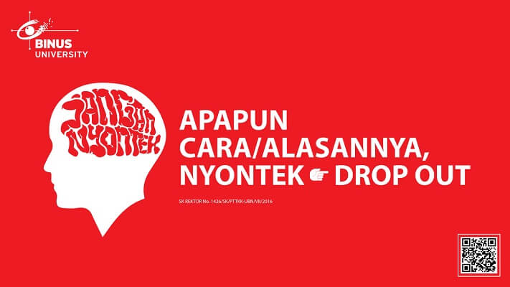

SOFTWARE YANG DIGUNAKAN:
Software will be used:
- Dev-C++ 5.11

FILE YANG DIKUMPULKAN:
File must be collected:
- [NIM].CPP

PERHATIAN!
Attention!
- Bagi yang mengerjakan tidak sesuai dengan soal, maka akan diberikan nilai NOL (0)
For those who do not work in accordance with the exam case will be marked as ZERO (0)
- Bagi yang mengerjakan tidak sesuai dengan software dan versi yang telah ditetapkan, maka akan tetap dikoreksi dengan software dan versi yang telah ditetapkan
For those who do not work in accordance with the software and specific version will be corrected by the predefined software and version
- Kompres semua jawaban yang akan diunggah. Pastikan format pengumpulan nama file dan ekstensi sesuai dengan format berikut: [NIM]-[NAMA].zip
Compress all file that will be uploaded. Make sure the format for collecting file name and extension according to the following format: [NIM]-[NAME].zip

Soal
Case

Jpassword Saver

BlueJackX is a software house company that specializes in building software products. Jpassword Saver is one of its projects that needs to be done this week. The purpose of this application is to help user manage their accounts, platforms username, and their password. The client asked to use AVL tree data structure due to its good complexity in doing searching operations and using C programming language. The descriptions of the program are:
- The program consists of 3 menus:
1. View Accounts
2. Insert Account
3. Delete Account
4. Exit
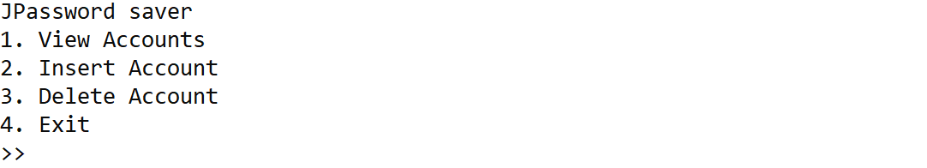
Figure 1. Main Menu
- If user chooses a number that is not 1-4, print invalid input
- If user chooses View Account (Menu 1):
  - If there is no data in the AVL, print “There is no data…”
  - Otherwise, ask user to input display method. Validate that the method must be either “Pre”, “In”, or “Post” without quotes and case sensitive
Figure 2. Choose Show Method

    - If user chooses “Pre”, then show the data using Pre-Order method
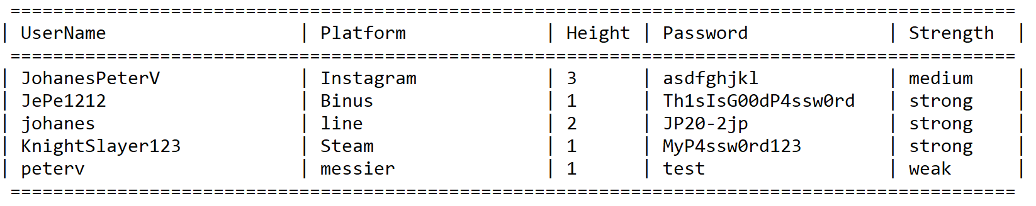
Figure 3. View Accounts in Pre-Order
    - If user chooses “In”, then show the data using In-Order method
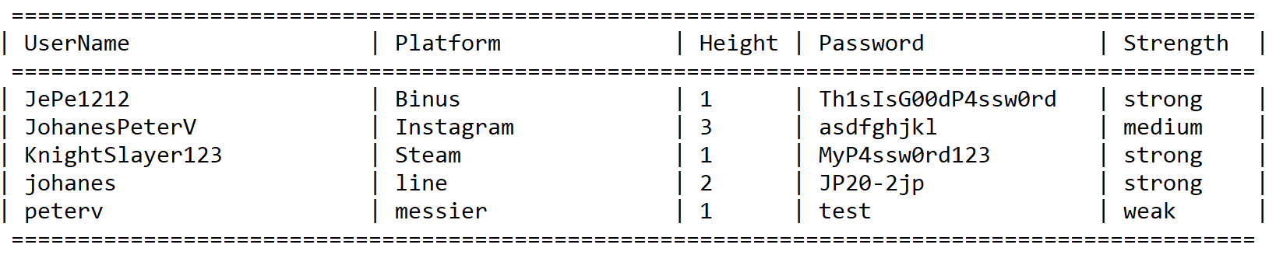
Figure 4. View Accounts in In-Order
    - If user chooses “Post”, then show the data using Post-Order method
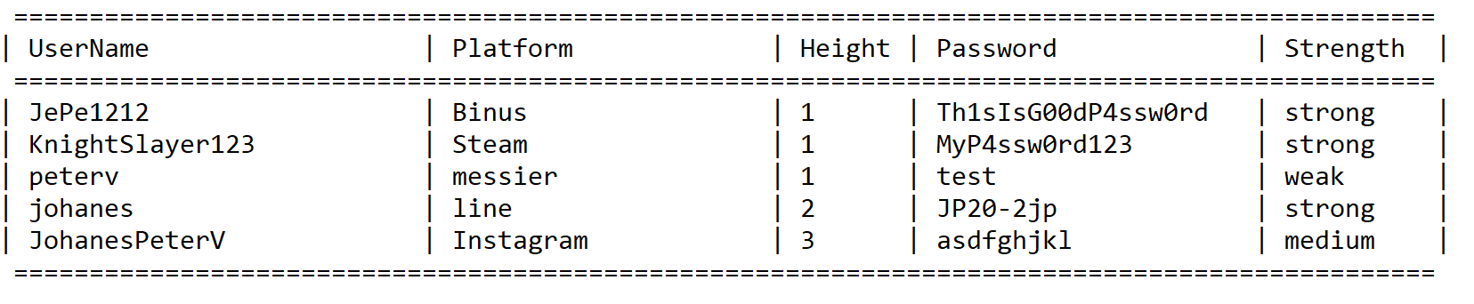
Figure 5. View Accounts in Post-Order
- If user chooses Insert Account (Menu 2):
  - Ask user to input the following data:
    - UserName
      - Validate that the length must be between 6 and 80 characters.
    - Platform
      - Validate that the length must be between 6 and 80 characters.
    - Password
      - Validate that the password length must be less than 60 and password strength must not invalid.
  - Generate password strength based on the criteria below
    - Password Strength factor(s):
      - Password length is more than 6 character(s)
      - Password contains at least an uppercase letter
      - Password contains at least a lowercase letter
      - Password contains at least one number
    - Password Strength criteria:
      - Invalid if password only fulfills one strength factor
      - Weak if password fulfills two strength factors
      - Medium if password fulfills three strength factors
      - Strong if password fulfills all strength factors
  - After that, ask user for insert confirmation, validate the input must be either “Y” or “N”
  - If user choose “Y”, insert the data to the AVL tree with Account Name as the key, otherwise don’t save the data and redirect back to main menu
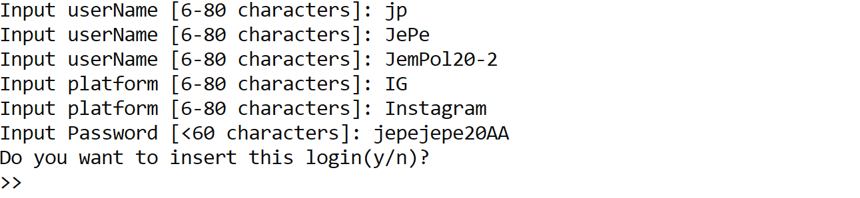
Figure 6. Insert Account
- If user chooses Delete Account (Menu 3):
  - Print all existing accounts (you can choose between in-order, pre-order, or post-order method)
  - Ask user to input username
    - Validate if user inputs “cancel”, redirect back to main menu
    - Otherwise, validate the account name must exist in the AVL Tree before confirming for deletion
    - After that ask user for confirmation, validate the input must be either “y” or “n” (case sensitive)
      - If user choose “y” delete the inputted account name data from AVL Tree
      - Otherwise, if user choose “n” redirect user to main menu
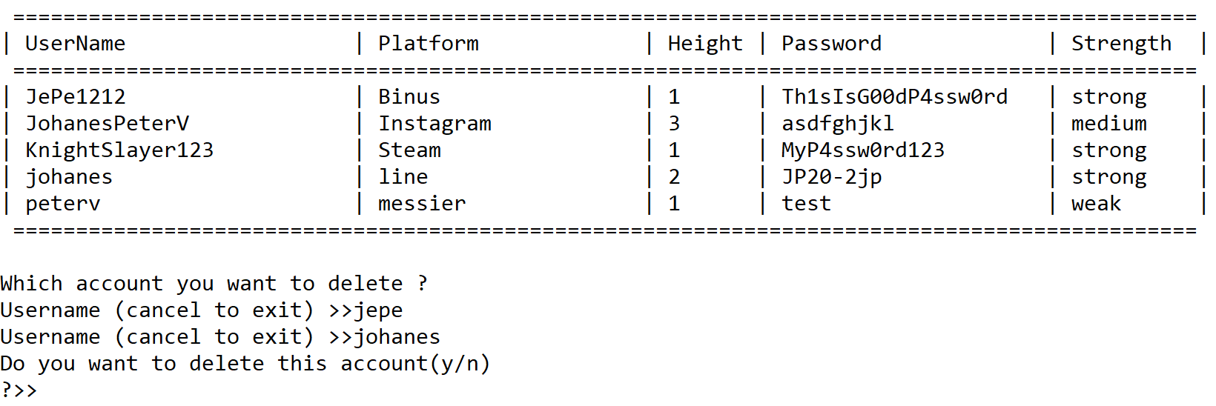
Figure 7. Delete Account
- If user chooses Exit (Menu 4), remove all accounts in the AVL Tree and close the program

Please run the EXE file to see the sample program

